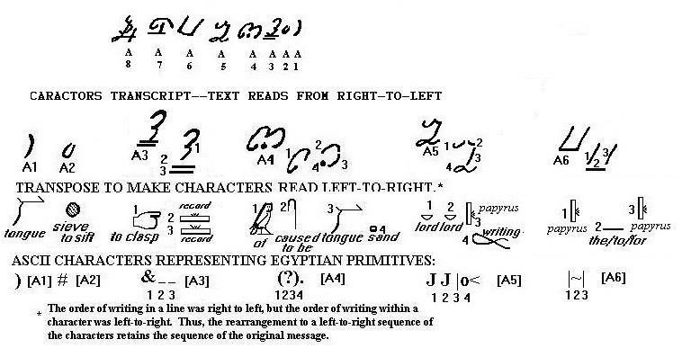

````` SPOKEN [A1] ABRIDGED [A2] PRESERVED record record [A3] of WORD PROMISE [A4] SACRED PLATES writings [A5] PLATES the-to-for² PLATES [A6]

Text interpreting A8 as four separate characters—as only one character, it makes no sense. Alternative ONE.
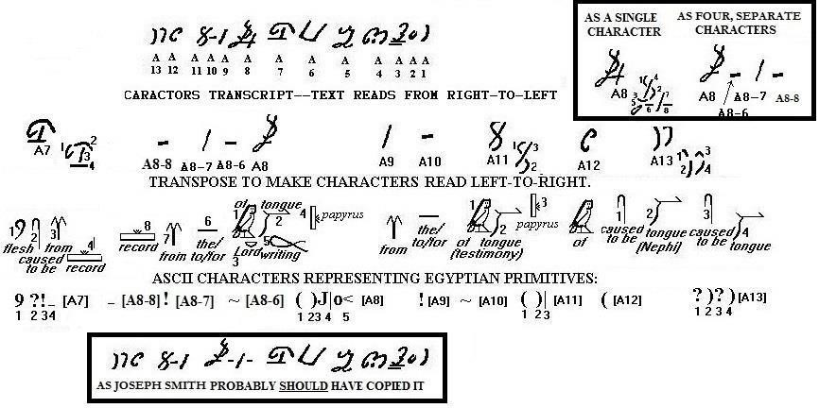

````` CHRIST-DIRECTED INTERPRETATION [A7] record
[A8-8] from [A8-7] the-to-for¹ [A8-6] TESTIMONY GOD
PLATES writings [A8] from [A9] the-to-for¹ [A10]
TESTIMONY PLATES [A11] of [A12] WORD WORD
[A13]

Text interpreting A8 as TWO separate characters—as only one character, it makes no sense. Alternative TWO.
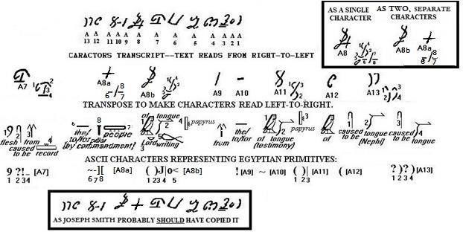
````` CHRIST-DIRECTED INTERPRETATION [A7] BY COMMANDMENT [A8a] TESTIMONY GOD PLATES
writings [A8b] from [A9] the-to-for¹ [A10]
TESTIMONY PLATES [A11] of [A12] WORD WORD [A13]

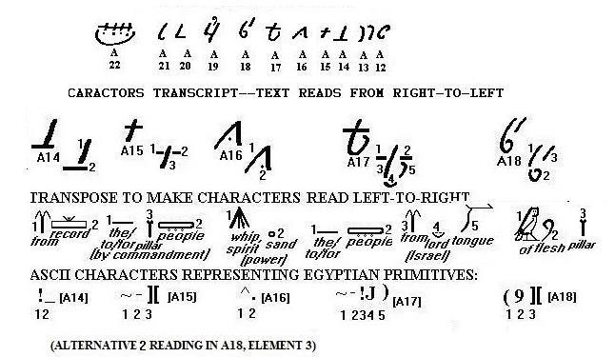

````` INTERPRETATION [A14] BY COMMANDMENT [A15]
POWER [A16] the-to-for² PEOPLE from GOD SPOKEN
[A17] CHRIST-INSPIRED GIFT [A18]

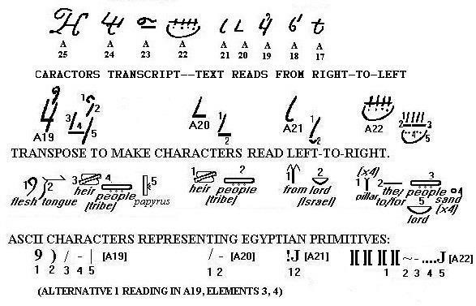

````` CHRIST SPOKEN TRIBE PLATES [A19] TRIBE [A20] from
GOD [A21] MARVELOUS GIFT the-to-for² PEOPLE COVENANT
GOD [A22]

Text interpreting A24 as only one character. Alternative ONE.
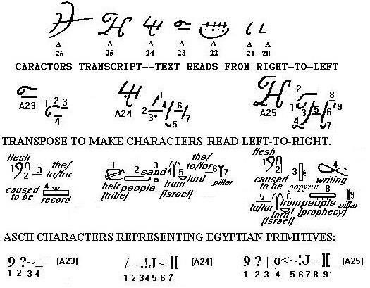
````` CHRIST-DIRECTED the-to-for³ record [A23] TRIBE
PROMISE from GOD the-to-for¹ GIFT [A24] CHRIST-
DIRECTED PLATES writings the-to-for⁴ from GOD
PROPHECY [A25]

Text interpreting A24 as THREE characters. Alternative TWO.
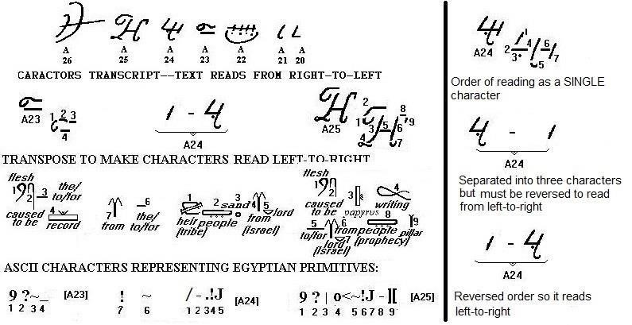
````` CHRIST-DIRECTED the-to-for3 record [A23] from thetofor¹ TRIBE PROMISE from GOD [A24] CHRIST- DIRECTED PLATES writings the-to-for⁴ from GOD
PROPHECY [A25]

Text interpreting A24 as TWO characters. Alternative THREE.
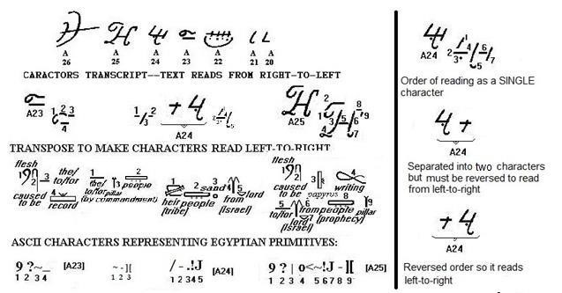

````` CHRIST-DIRECTED the-to-for3 record [A23] BY
COMMANDMENT [A24b] TRIBE PROMISE from GOD [A24a] CHRIST-DIRECTED PLATES writings the-to-for⁴ from GOD PROPHECY [A25]

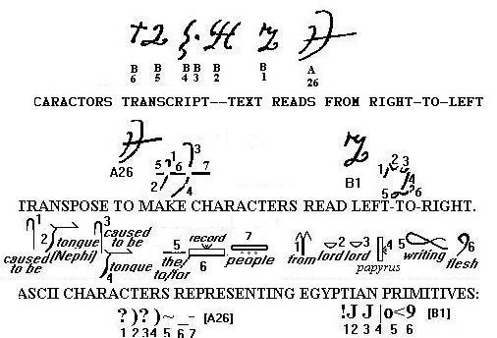

````` WORD WORD the-to-for record PEOPLE [A26] from
SACRED PLATES writings CHRIST [B1]

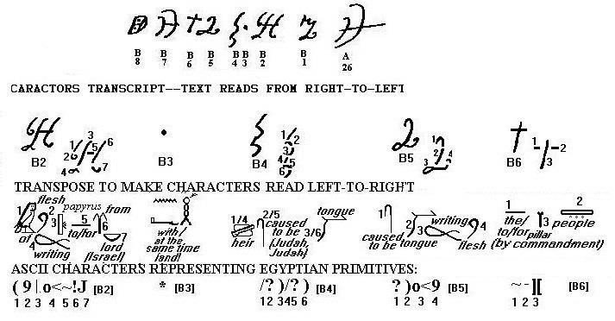

````` CHRIST-INSPIRED PLATES writings the-to-for⁴ from
GOD [B2] AND [B3] heir WORD heir WORD [B4]
WRITTEN CHRIST [B5] BY COMMANDMENT [B6]

Here, B7 is taken to read ‘NEPHITE RECORD’ as the beginning of a sentence where the subsequent use of ‘Laman and Nephi’ to B16 is taken to be a complete sentence. Alternative ONE.
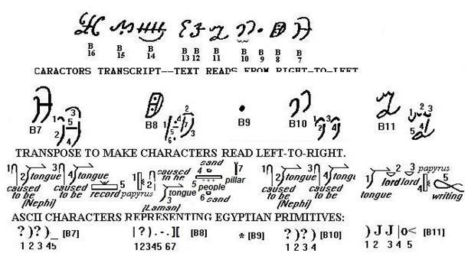

````` WORD WORD record [B7] PLATES WORD PROMISE
PEOPLE PROMISE GIFT [B8] AND [B9] WORD WORD [B10] SPOKEN SACRED PLATES writings [B11]

But, B7 COULD also mean ‘NEPHITE PEOPLE’ followed by names of Laman and Nephi. In this case B7 is NOT the start of the sentence, but is a continuation until B16. Alternative TWO.
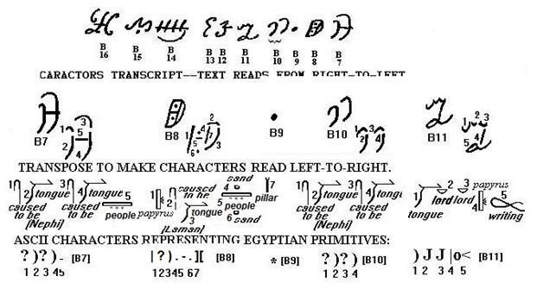

````` WORD WORD PEOPLE [B7] PLATES WORD PROMISE
PEOPLE PROMISE GIFT [B8] AND [B9] WORD WORD [B10] SPOKEN SACRED PLATES writings [B11]

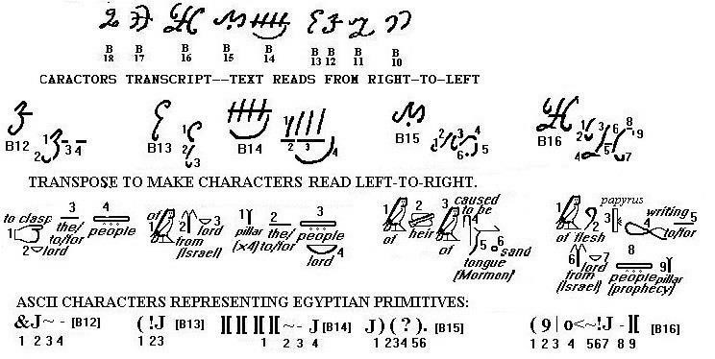

````` PRESERVED GOD the-to-for⁴ PEOPLE [B12] of from
GOD [B13] MARVELOUS GIFT the-to-for¹ PEOPLE GOD
[B14] of heir of WORD PROMISE [B15] CHRIST-
INSPIRED PLATES writings the-to-for⁴ from GOD
PROPHECY [B16]

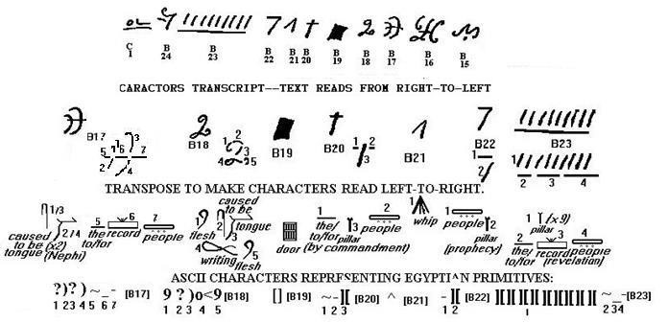

````` WORD WORD the-to-for¹ record PEOPLE [B17]
CHRIST WRITTEN CHRIST [B18] BYWAYOF [B19] BY
COMMANDMENT [B20] SPIRIT [B21] PROPHECY [B22]
REVELATION [B23]

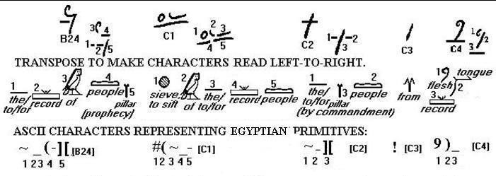

````` the-to-for³ record of PROPHECY [B24] ABRIDGED of the-to-for¹ record PEOPLE [C1] BY COMMANDMENT [C2] from [C3] CHRIST SPOKEN record [C4]
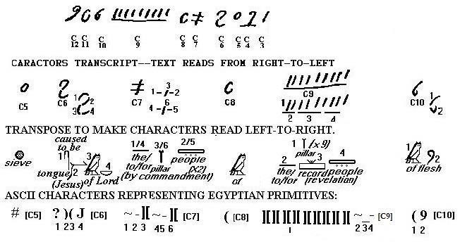

````` ABRIDGED [C5] WORD of GOD [C6] BY
COMMANDMENT BY COMMANDMENT [C7] of [C8]
REVELATION [C9] of CHRIST [C10]

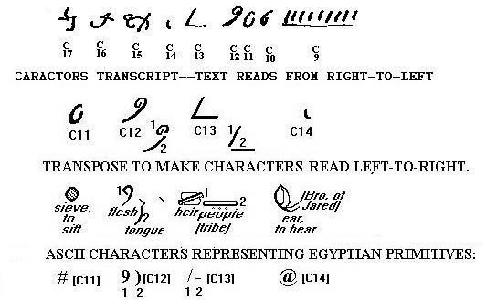

````` ABRIDGED [C11] CHRIST SPOKEN [C12] TRIBE [C13] TOHEAR/OBEY [C14]

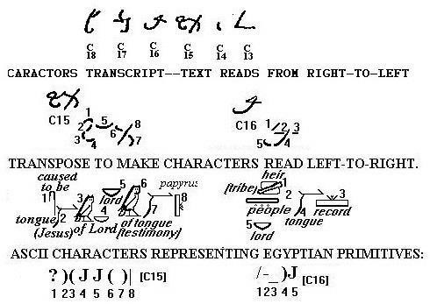

````` WORD of GOD GOD TESTIMONY PLATES [C15]
TRIBE record SPOKEN GOD [C16]

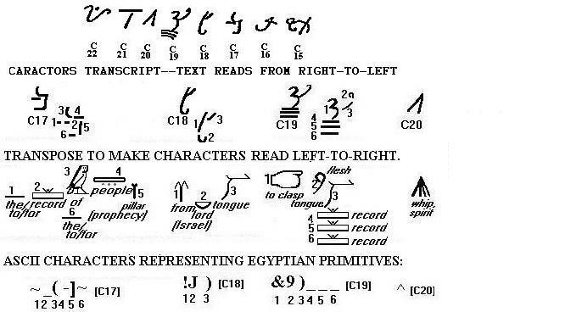

````` the-to-for¹ record of PROPHECY the-to-for² [C17]
from GOD SPOKEN [C18] PRESERVED CHRIST SPOKEN record record record [C19] SPIRIT [C20]

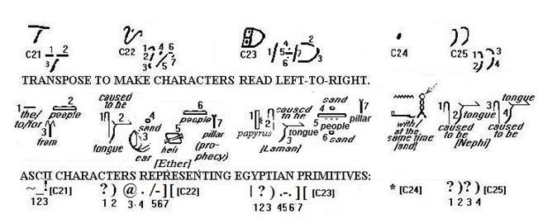

````` the-to-for¹ PEOPLE from [C21] WORD TOHEAR/OBEY
PROMISE heir PROPHECY [C22] PLATES WORD
PROMISE PEOPLE PROMISE GIFT [C23] AND [C24]
WORD WORD [C25]

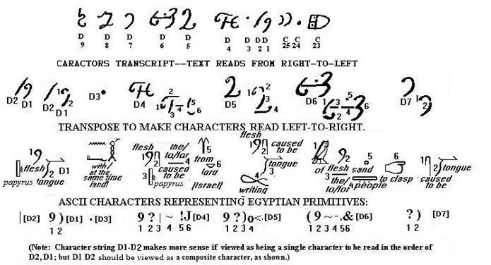

````` PLATES CHRIST SPOKEN [D2/1] AND [D3] CHRIST-
DIRECTED PLATES the-to-for⁴ from GOD [D4] CHRIST
WRITTEN [D5] CHRIST-INSPIRED the-to-for² PEOPLE
PROMISE PRESERVED [D6] WORD PROMISE [D7]

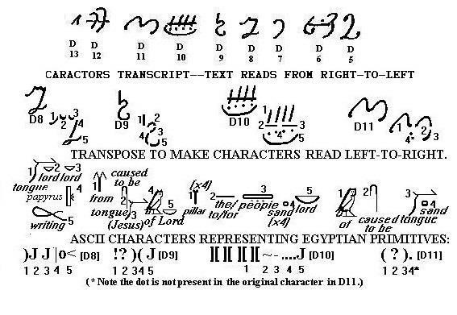

````` SPOKEN SACRED PLATES writings [D8] from WORD of GOD [D9] MARVELOUS GIFT the-to-for² PEOPLE COVENANT GOD [D10] of WORD PROMISE [D11]

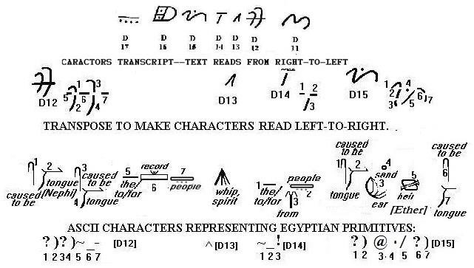

````` WORD WORD the-to-for¹ record PEOPLE [D12]
SPIRIT [D13] the-to-for¹ PEOPLE from [D14] WORD
TOHEAR/OBEY PROMISE heir WORD [D15]

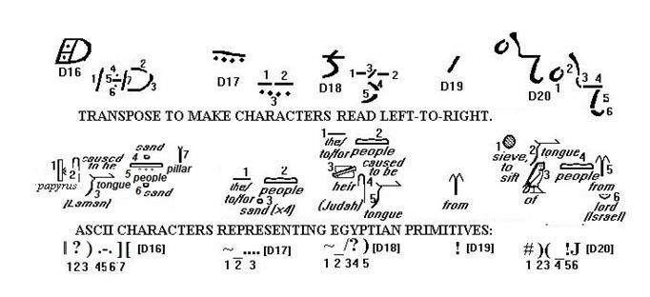

````` PLATES WORD PROMISE PEOPLE PROMISE GIFT
[D16] the-to-for² PEOPLE COVENANT [D17] the-to-for¹
PEOPLE heir WORD [D18] from [D19] ABRIDGED
SPOKEN of PEOPLE from GOD [D20]

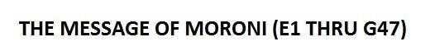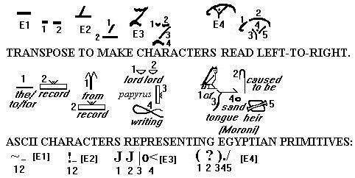

````` the-to-for³ record [E1] INTERPRETATION [E2]
SACRED PLATES writings [E3] of WORD PROMISE heir
[E4]

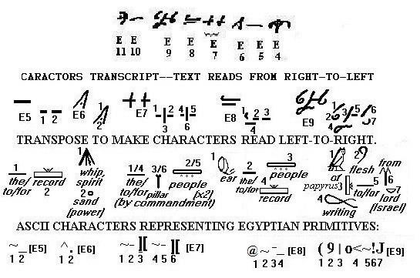
````` the-to-for3 record [E5] POWER [E6] BY
COMMANDMENT BY COMMANDMENT [E7]
TOHEAR/OBEY the-to-for² PEOPLE record [E8] CHRIST-
INSPIRED PLATES writings the-to-for⁴ from GOD [E9]

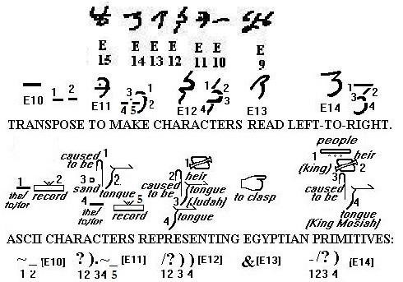
````` the-to-for³ record [ E10] WORD PROMISE the-to-for² record [E11] heir WORD SPOKEN [E12] PRESERVED [E13] KING WORD [E14]

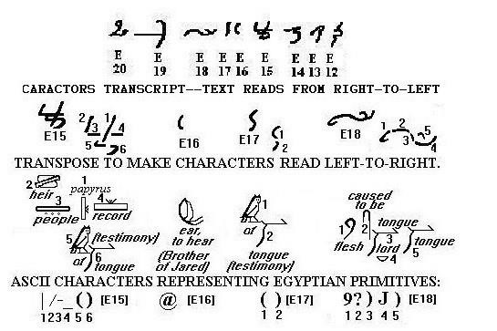
````` PLATES TRIBE record TESTIMONY [E15]
TOHEAR/OBEY [E16] TESTIMONY [E17] CHRIST
WRITTEN SPOKEN [E18]

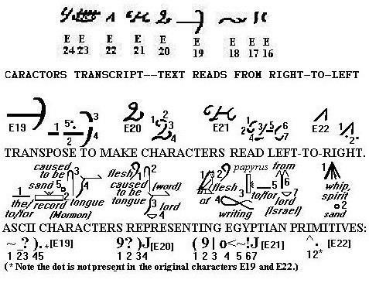
````` the-to-for¹ record WORD PROMISE [E19] CHRIST WRITTEN [E20] CHRIST-INSPIRED PLATES writings theto-for⁴ from GOD [E21] POWER [E22]

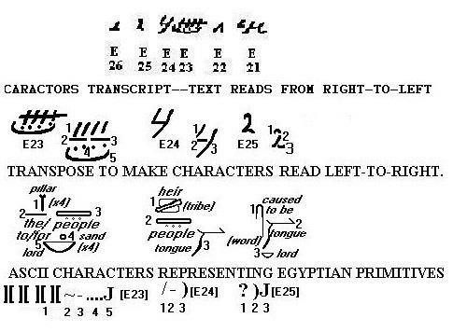
````` MARVELOUS GIFT the-to-for² PEOPLE COVENANT GOD
[E23] TRIBE SPOKEN [E24] WRITTEN [E25]
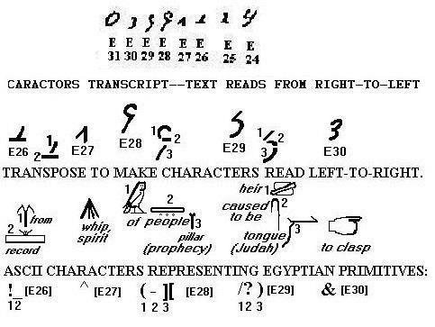

````` INTERPRETATION [E26] SPIRIT [E27] of PROPHECY
[E28] heir WORD [E29] PRESERVED [E30]

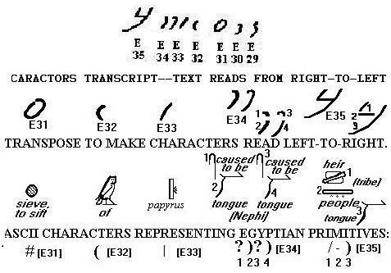
````` ABRIDGED [E31] of [E32] PLATES [E33] WORD WORD [E34] TRIBE SPOKEN

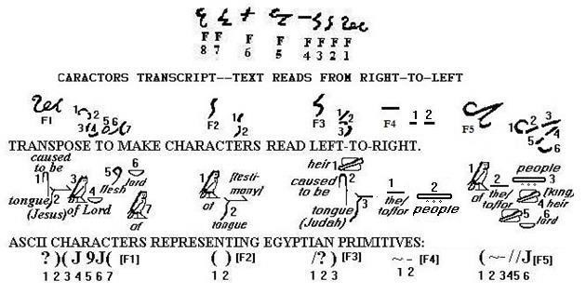
````` WORD of GOD CHRIST GOD of [F1] TESTIMONY [F2] heir WORD [F3] the-to-for² PEOPLE [F4] of the-to-for¹ KING heir GOD [F5]

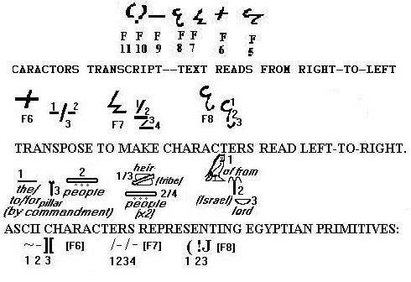
````` BY COMMANDMENT [F 6] TRIBE TRIBE [F7] of from GOD [F8]

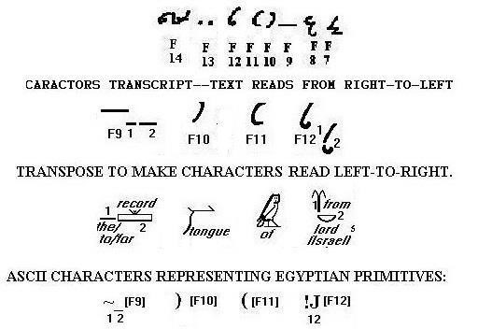
````` the-to-for³ record [F9] SPOKEN [F10] of [F11] from GOD [F12]

F15 as being intended as a SINGLE character. Alternative ONE
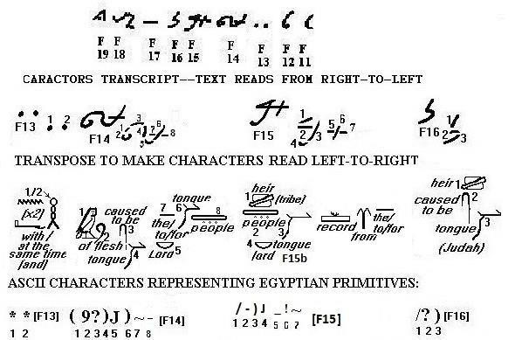

````` AND AND [F13] CHRIST-INSPIRED WORD GOD SPOKEN the-to-for² PEOPLE [F14] TRIBE SPOKEN GOD record from the-to-for¹ [F15] heir WORD [F16]

Taking F15 as being intended as FOUR separate characters. Alternative TWO.
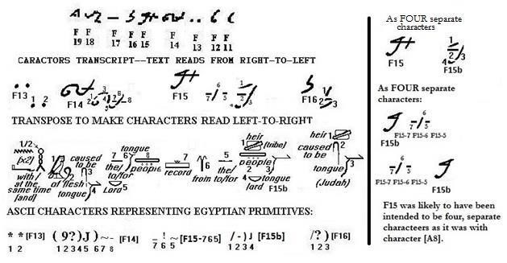

````` AND AND [F13] CHRIST-INSPIRED WORD GOD
SPOKEN the-to-for² PEOPLE [F14] record [F15-7] from
[F15-6] the-to-for¹ [F15-5] TRIBE SPOKEN GOD
[F15b] heir WORD [F16]

Taking F15 as being intended as TWO separate characters. Alternative THREE.
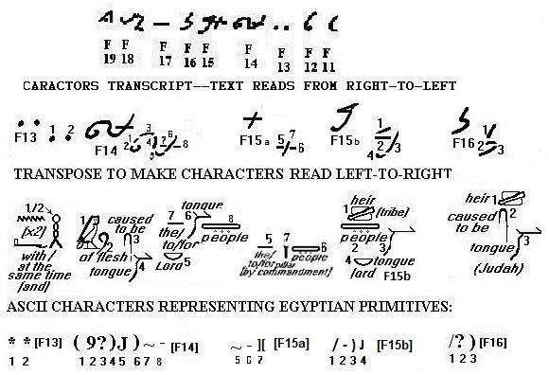
````` AND AND [F13] CHRIST-INSPIRED WRITTEN
SPOKEN the-to-for² PEOPLE [F14] BY COMMANDMENT [F15a] TRIBE SPOKEN GOD [F15b] heir WORD [F16]

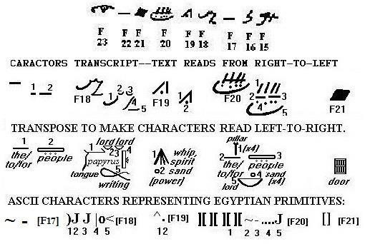
````` the-to-for³ PEOPLE [F17] SPOKEN SACRED PLATES writings [F18] POWER [F19] MARVELOUS GIFT thetofor² PEOPLE COVENANT GOD [F20] BYWAYOF [F21]

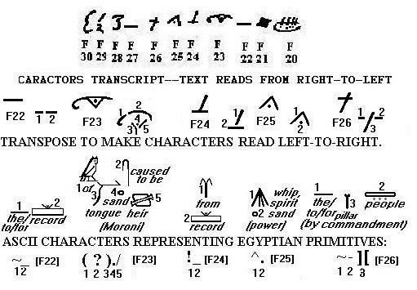
````` the-to-for³ record [F22] of WORD PROMISE heir
[F23] INTERPRETATION [F24] POWER [F25] BY
COMMANDMENT [F26]

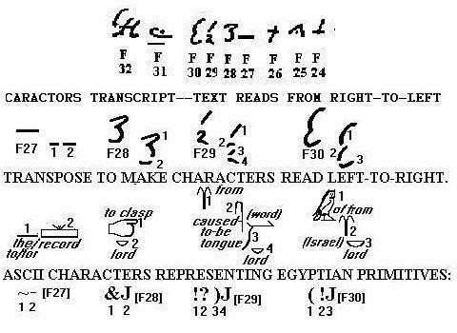
````` the-to-for³ record [F27] PRESERVED GOD [F28] from WRITTEN [F29] of from GOD [F30]

a single character Root 4 being ‘heir.’ Assumes Root 1 of F31 is ‘ear’ rather than ‘of.’ Also assumes that Root 7 should be there to make it read ‘Mormon.’ Alternative ONE.
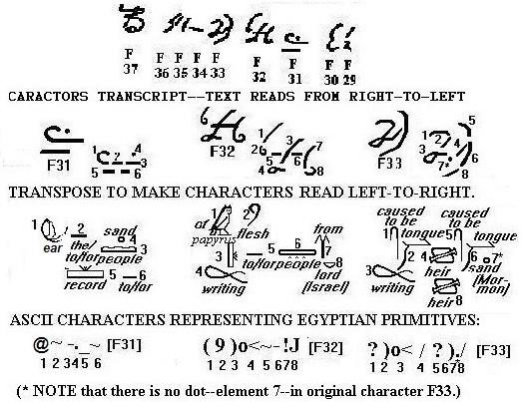
````` TOHEAR/OBEY the-to-for³ PEOPLE PROMISE record the-to-for² [F31] CHRIST-INSPIRED PLATES writings theto-for⁴ PEOPLE from GOD [F32] WRITTEN heir WORD PROMISE heir [F33]{1}

Text interpreting F33 as THREE characters AND Root 4 being ‘gift.’ Assumes Root 1 of F31 is ‘of’ rather than ‘ear.’ Also assumes that Root 7 should be there to make it read ‘Mormon.’ Alternative TWO.
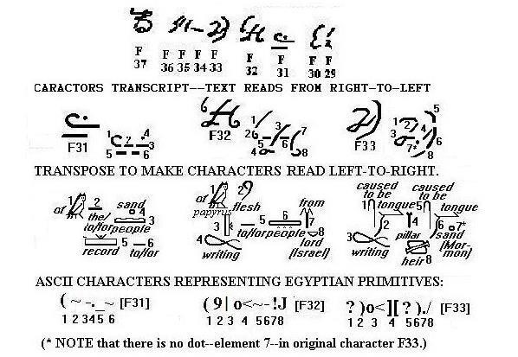
````` of the-to-for³ PEOPLE PROMISE record the-to-for²
[F31] CHRIST-INSPIRED PLATES writings the-to-for⁴
PEOPLE from GOD [F32] WRITTEN GIFT WORD
PROMISE heir [F33]{2}

Text interpreting F33 as THREE characters AND Root being ‘from.’ Assumes Root 1 of F31 is ‘of’ rather than ‘ear.’ Also assumes that Root 7 should be there to make it read ‘Mormon.’ Alternative THREE.
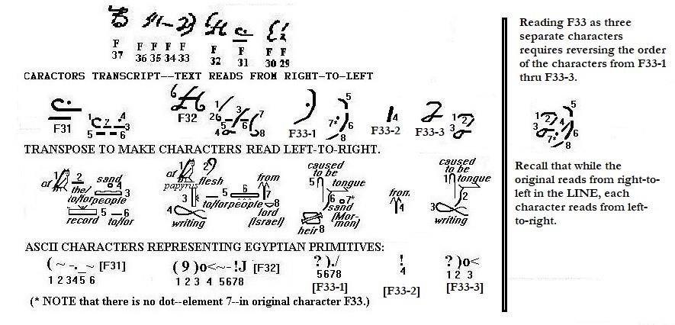
````` of the-to-for² PEOPLE PROMISE record the-to-for²
[F31] CHRIST-INSPIRED PLATES writings the-to-for⁴ PEOPLE from GOD [F32] WORD PROMISE heir [F33-1] from [F33-2] WRITTEN [F33]{3}

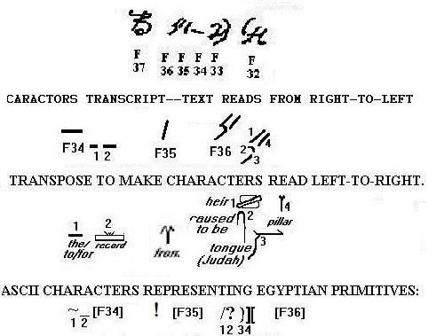

````` the-to-for³ record [F34] from [F35] heir WORD GIFT [F36]

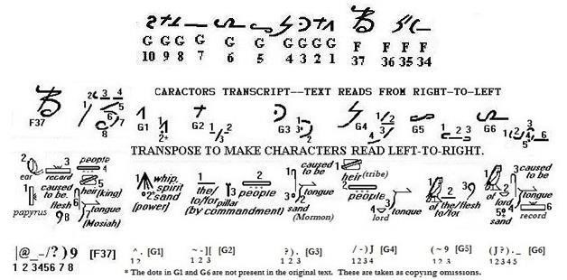

````` PLATES TOHEAR/OBEY record KING WORD CHRIST
[F37] POWER [G1] BY COMMANDMENT [G2] WORD
PROMISE [G3] TRIBE SPOKEN GOD [G4] of the-to-for¹
CHRIST [G5] of GOD WORD PROMISE record [G6]

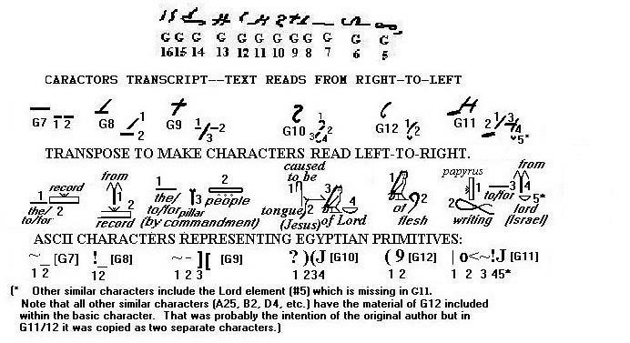

````` the-to-for³ record [G7] INTERPRETATION [G8] BY
COMMANDMENT [G9] WORD of GOD [G10] CHRIST- INSPIRED [G12] PLATES writings the-to-for⁴ from GOD [G11]

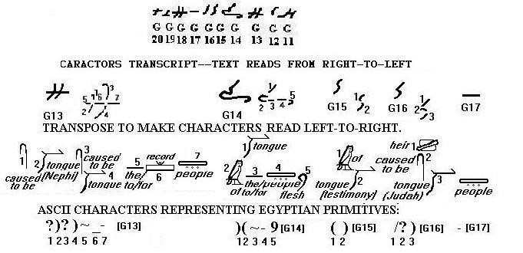

````` WORD WORD the-to-for¹ record PEOPLE [G13]
SPOKEN of the-to-for¹ PEOPLE CHRIST [G14]
TESTIMONY [G15] heir WORD [G16] PEOPLE [G17]

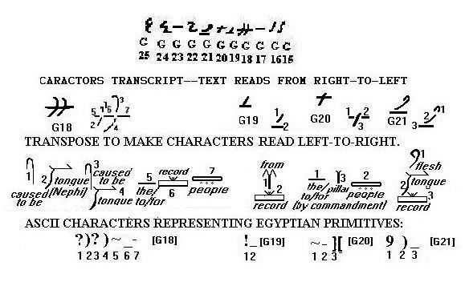

````` WORD WORD the-to-for¹ record PEOPLE [G18]
INTERPRETATION [G19] BY COMMANDMENT [G20] CHRIST SPOKEN record [G21]

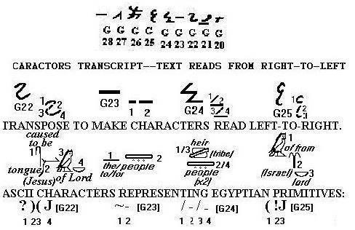

````` WORD of GOD [G22] the-to-for³ PEOPLE [G23] TRIBE TRIBE [G24] of from GOD [G25]

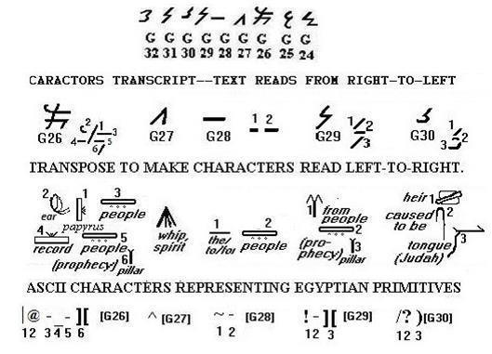

````` PLATES TOHEAR/OBEY PEOPLE record PROPHECY
[G26] SPIRIT [G27] the-to-for³ PEOPLE [G28] from
PROPHECY [G29] heir WORD [G30]

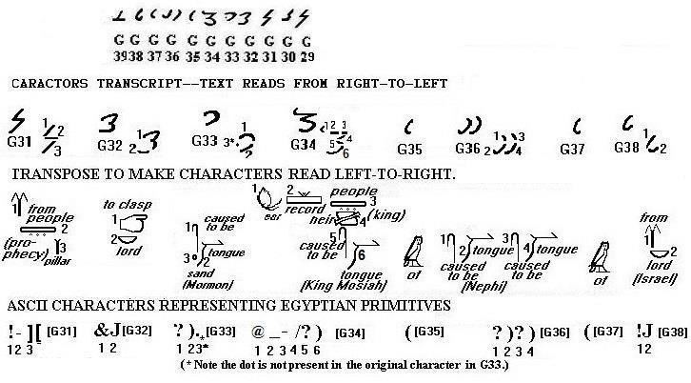

````` from PROPHECY [G31] PRESERVED GOD [G32]
WORD PROMISE [G33] TOHEAR/OBEY record KING
WORD [G34] of [G35] WORD WORD [G36] of
[G37] from GOD [G38]

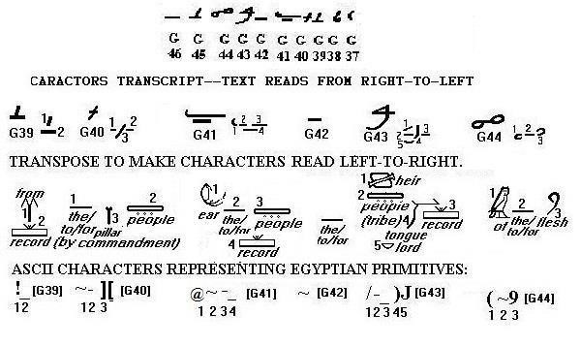

````` INTERPRETATION [G39] BY COMMANDMENT [G40] TOHEAR/OBEY the-to-for² PEOPLE record [G41] thetofor¹ [G42] TRIBE record SPOKEN GOD [G43] of thetofor¹ CHRIST [G44]

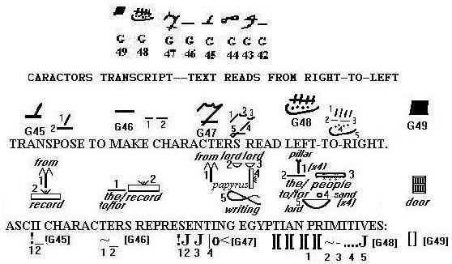

````` INTERPRETATION [G45] the-to-for³ record [G46] from SACRED PLATES writings [G47] MARVELOUS GIFT theto-for² PEOPLE COVENANT GOD [G48] BYWAYOF [G49]\

